**OUTPUT OF THE PROGRAM IMPLEMENTED USING C- LANGUAGE 🡺**

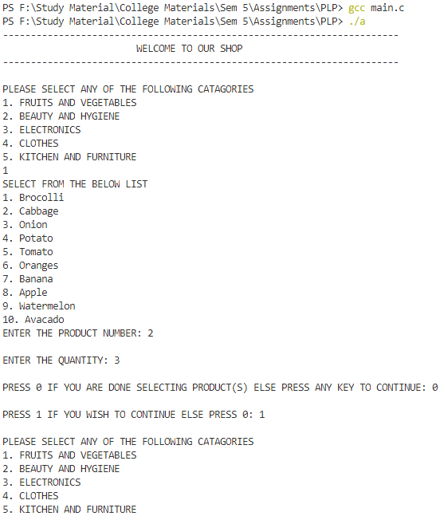

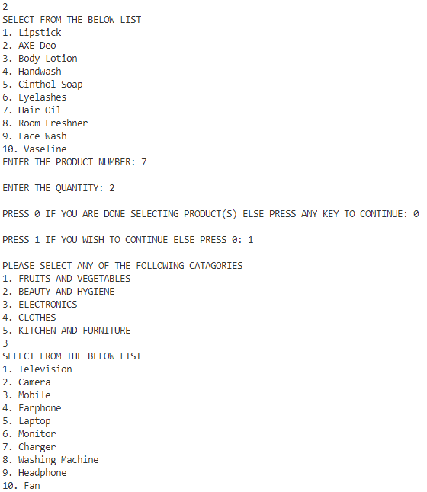

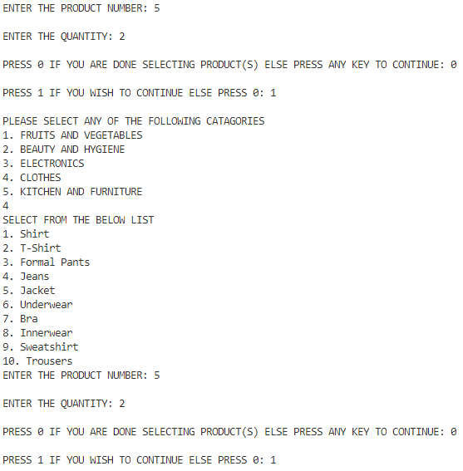

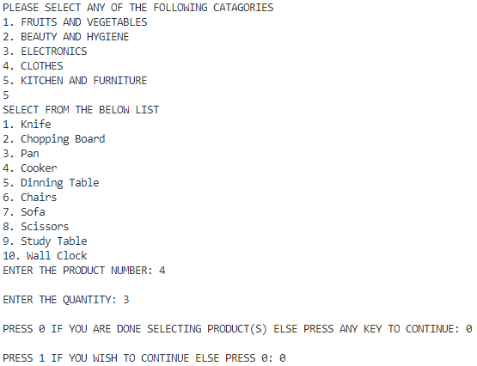

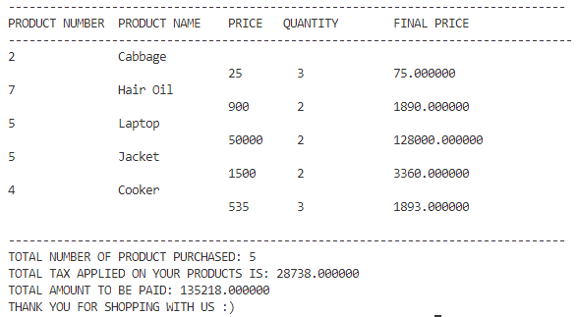

**5 Files with different category with their distinct products used is C programming 🡺**

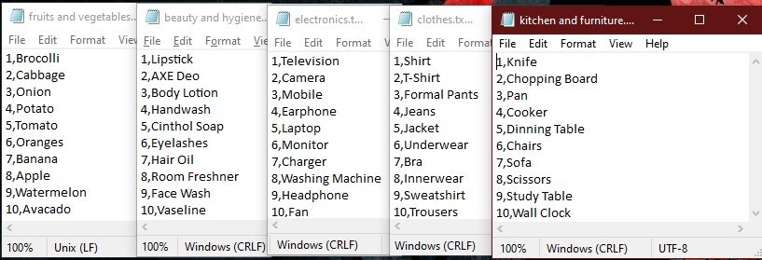

**OUTPUT FOR PROGRAM IMPLEMENTED USING JAVA- LANGUAGE 🡺**

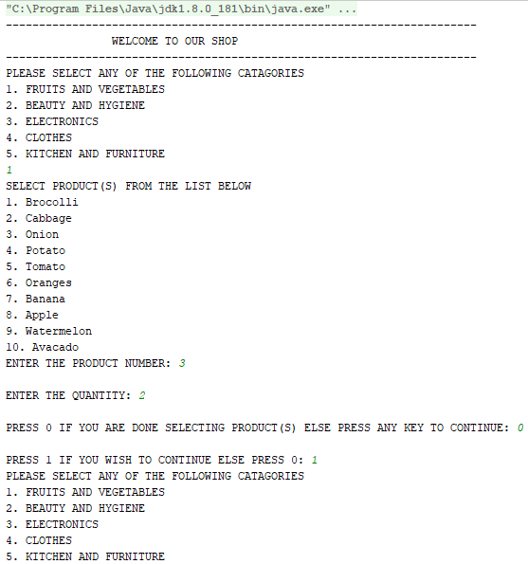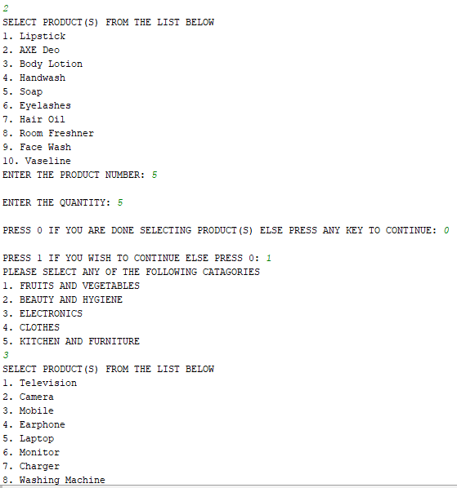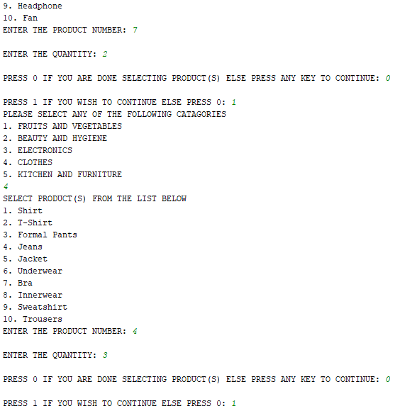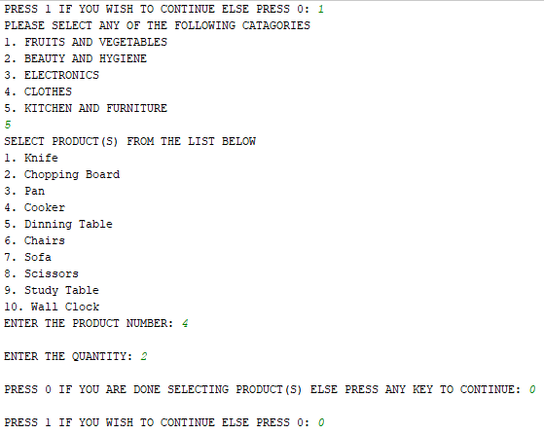

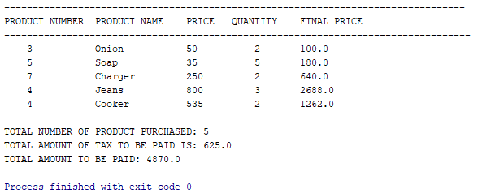

**5 Files with different category with their distinct products used is JAVA programming 🡺**

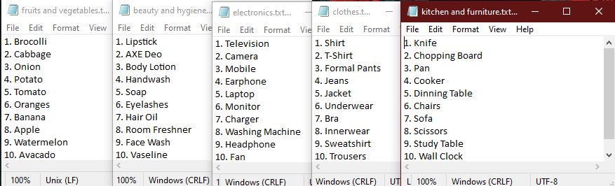

**Comparison of java and C with respect to ease of writing:-**

If we discuss on the ease of writing program then I will say that java is easy as compared to C language. In the scenario we were asked to develop a program for a billing system according to tax slots given and the tax slots can be divided depending on the seller. The program has to be generic which means that there can be any number of customers and many number of products in a shop due to which we will have large number of data that needs to be stored. For that if we can use database, files, array, gson, etc depending on what programmer feels easy. Here I have used files and array. File handling in java is much easier than file handling in C. In java, there are many methods using which we can handle file very easy whereas C doesn’t provide those features. For example in java I read file and line by line stored it in an array and then later after selecting products I was able to print the name of the product without any whitespaces or number using substring but in C when I wanted to do the same thing I wasn’t able to do because C cannot read files and store it in an array as easily as compared to java. In C using file pointer, each file separated by comma has been taken and in the loop each character is read and as the comma is read, the characters after that is getting stored in a character array. This is a very complex way of handling file. It effects readability, writability, complexity and effectiveness of a program. Anyone reading C file will get confused because what java can do in one line C has to do in many lines of codes. Its like decoding java methods.

As per the scenario and after understanding the difficulties in both the programming language, I prefer java over C to deal with this type of problem with large number of data. Printing product name was the most difficult part which I came across with. Java has exceptional handling features. For example if a file is not present in system then we can use exceptional handling in java to tell that file not found and the program will run error free but in C we can’t do that because it doesn’t provide such feature to handle with these kind of exception. In some cases C will be easy than java but here I found difficulty in doing in C. C is mostly used in system programming because it is easy to develop OS or drivers or anything easily and efficiently. Java cannot be used for this because it will make the program complicated and dealing with assembly language is not easy with java.

**Comparison with respect to system utilization:-**

**Memory utilization by C- Programming 🡺**

Here a.exe is our executable file whose PID is 6292 and total memory usage is 1888k(shown in fig1.5.3) and current memory while the program is running is 268k(shown in fig 1.5.2). CPU utilization we got it as 9%.(shown in fig 1.5.1).

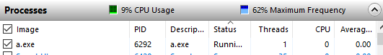

**Fig 1.5.1: CPU utilization found out using task manager**

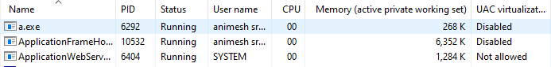

**Fig 1.5.2: Current Memory utilization found out using task manager**

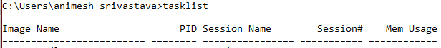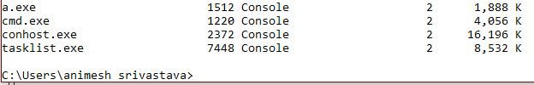

**Fig 1.5.3: Memory utilization found out using cmd**

**Memory utilization by Java- Programming 🡺**

Here idea64.exe is our executable file whose PID is 12856 and total memory usage is 620552k(shown in fig1.5.6) and current memory while the program is running is 596144k(shown in fig 1.5.5). CPU utilization we got it as 20%(shown in fig 1.5.3)

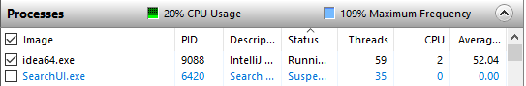

**Fig 1.5.4: CPU utilization found out using task manager**

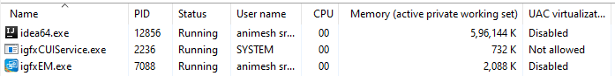

**Fig 1.5.5: Current Memory utilization found out using task manager**

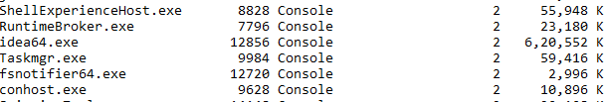

**Fig 1.5.6: Memory utilization found out using cmd**

Therefore after comparing memory utilization and CPU utilization it can be seen that memory and CPU utilized by JAVA program is more than C program. Therefore in terms of memory and CPU utilization, C is more efficient than JAVA because C program is consuming less memory and its CPU usage is also less.